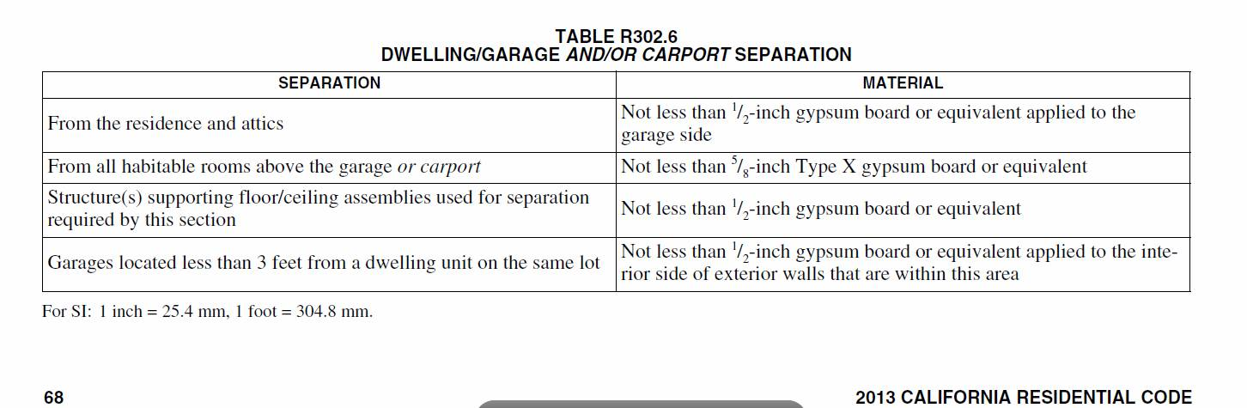

Oakland still requires 5/8” type X gyp board where the above table requires 1/2”